RETURNING ATHLETE
AVUHSD ONLINE ATHLETIC CLEARANCE PROCESS

Step-by-step instructions for completing the online process with screen shots matching each step are listed below. Current physicals must be on file in the athletics office (within one year or less of date signed by doctor). If you have any questions contact your school’s athletic secretary or athletic director. You will need insurance information and student present in order to complete the process.
Screen-by-Screen Instructions
- Go to www.athleticclearance.com and Sign In with your User Name and Password
- Click on “Start Clearances Here”.
- Select school year as 2019 - 2020. Select your high school. Select sport. Click “Submit” when finished.
- Since you are already in the system, click on the drop down menu that reads “Select Student” and select the student’s name. Please verify all information is up to date.
- *Do not upload any documents; physical document (Blue Card) must be on file in the athletics office. Click “Save”
- Answer all yes or no questions. If answer is yes to any question, type a brief description of the issue. Click “Save” when finished.
- Click the drop down menu that reads “Select Parent/Guardian”, and verify that all information is up to date.
- Read boxes and add all signatures for guardian and student. Click “Submit” when finished.
- Additional documents can be found on the confirmation page. These documents are also available in the athletics office.
- Once you reach the confirmation screen, the online clearance process is complete. At this time, you may add any additional sports the student is interested in trying out for. Mark the check box acknowledging parent/guardian electronic signature. We will finalize this acknowledgment with the signature on the physical form.

A confirmation email will be sent stating you have completed the online process, and another will be sent to you once the student is fully cleared. Athletic clearance is pending until physical is verified, academic eligibility is checked, and any transfer documentation is approved by CIF.

Screen Shots (Match numbers from above)
1  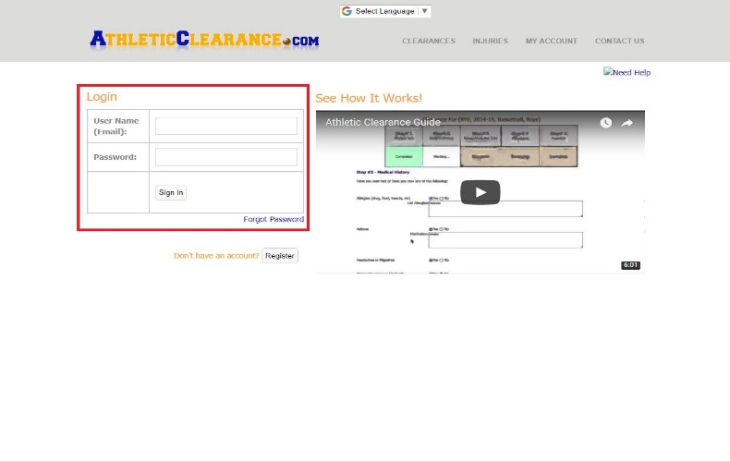 | 2  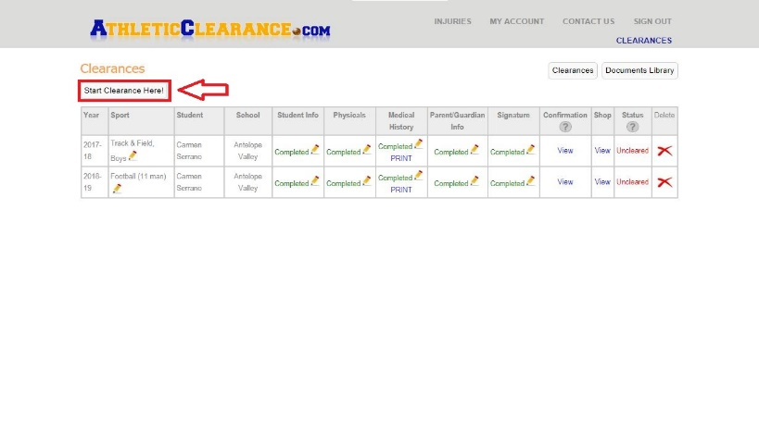
3 | 4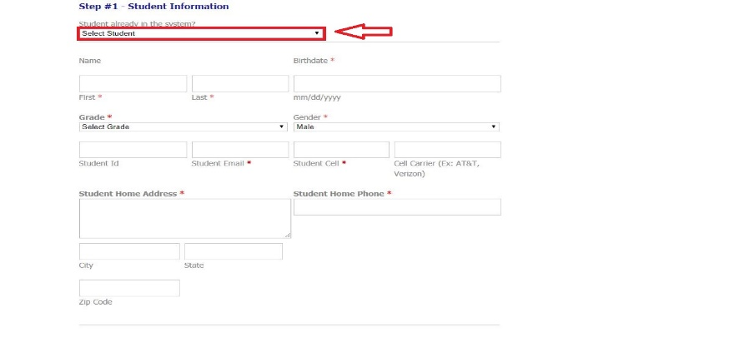
5  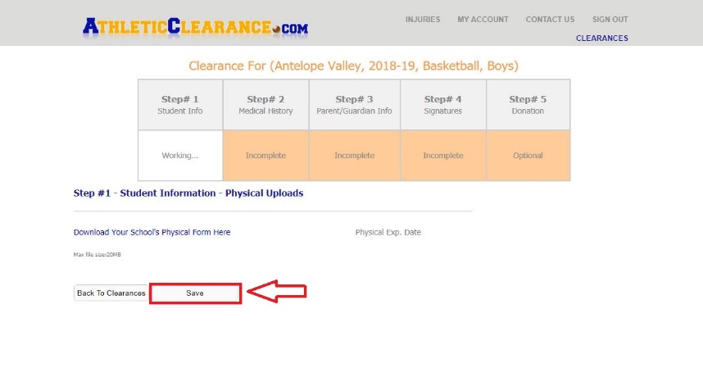 | 6
7  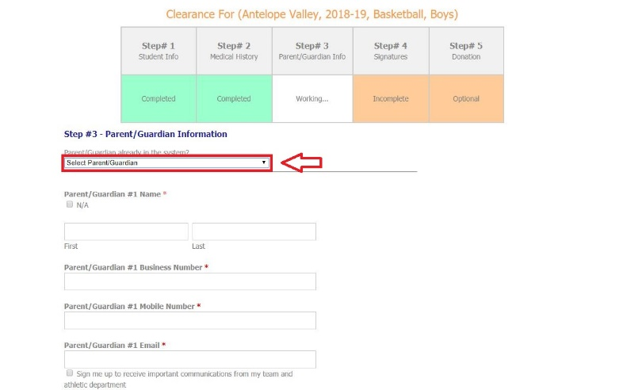 | 8
9  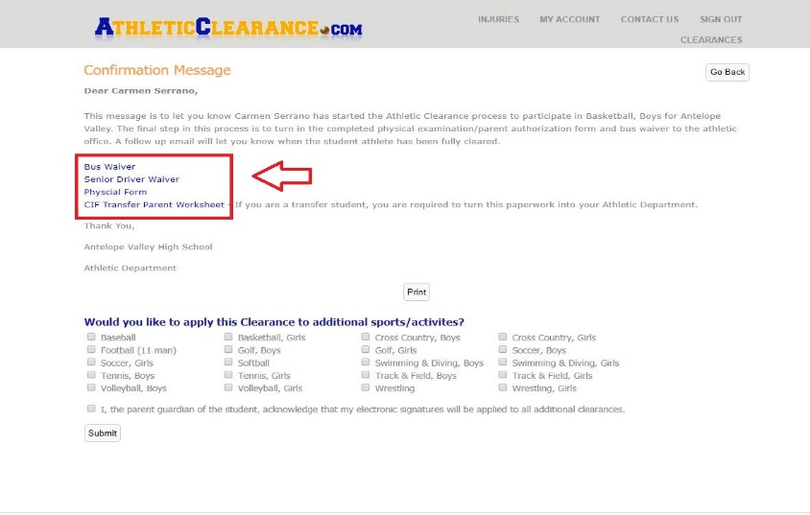 | 10  