Our District requires every student to be registered On-Line via *InfoSnap* a program which can be accessed by visiting the Parent Portal of PowerSchools. Log onto <https://powerschool.avhsd.org> “Create an Account” using the Codes listed here. Instructions will be provided for you.

Powerschool Access ID # _________________ Access Password # __________________



**Student *History of Schools, Language* Survey and SPECIAL SERVICES**

***Attention Parents / Guardians:* Please assist us in our effort to ensure accurate record keeping for your student. It’s extremely important that you provide the following information (to the Best of your Ability).**

*(If more space is needed, please inform the Clerk assisting with your registration.)*

* ***Home Language Survey***

**US School Entry Date:**  ________________ **California School Entry Date**: ________________

**Student’s First Language:**  _____________ **Most Frequent Home Language:** _____________

**Parent Language when speaking to child:** _______________________

**Frequent Language of Adults in Home:** *__________________________*

* ***Special Services***

**Special Education** __________ **504 Plan**  __________ **English Learner** __________

**Adult Ed** __________ **GATE** __________ **SST** __________ **Migrant** __________

**SARB**__________ **Ind. Study** __________ **Continuation** __________

**Opportunity** __________ **Court School** __________ **Juv. Hall / Camp** _________

**Suspended Last 3 Years?** __________ **School yr.** __________ **Suspension date:** __________

**Expelled / Expulsion Hearing? Yes / No If yes, please list date: _____________**

**Cleared Expulsion Terms? Yes / No**

**Convicted of a Felony? Yes / NO**

* **Has *student been******withdrawn* from previous school?** **Yes / No**  **Date Withdrawn**: **________________**
* **Has Student been enrolled under any other names while attending other high school(s)?**

**If so,** **please provide other last / surnames used:**  **________________________**

* ***If your Student is entering our District******from out of State****,* ***please list below - any Schools in California that He or She may have attended in the past, including Elementary.***

***History of Schools***

**GRADE** **SCHOOL NAME** **ADDRESS**  **CITY,STATE** **DATES ATTENDED**

|  |  |  |  |  |
| --- | --- | --- | --- | --- |
|  |  |  |  |  |
|  |  |  |  |  |
|  |  |  |  |  |
|  |  |  |  |  |
|  |  |  |  |  |
|  |  |  |  |  |
|  |  |  |  |  |
|  |  |  |  |  |

***By signing this document, I confirm that this information is accurate to the best of my knowledge:***

***Parent / Guardian __________________________________ Date: ______________***

*Revised /ls 08/21/15*

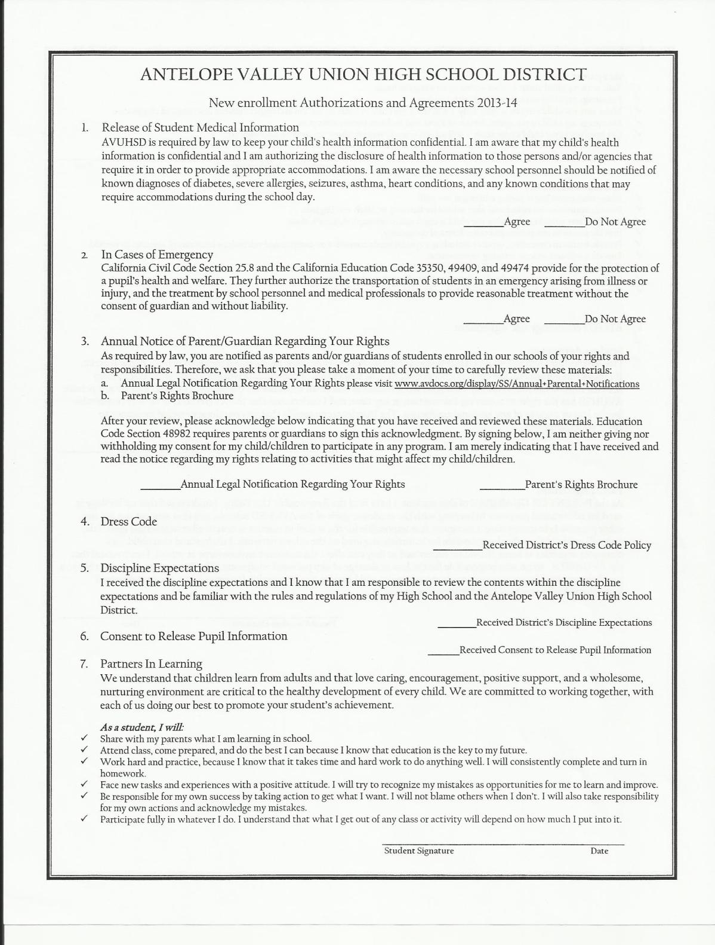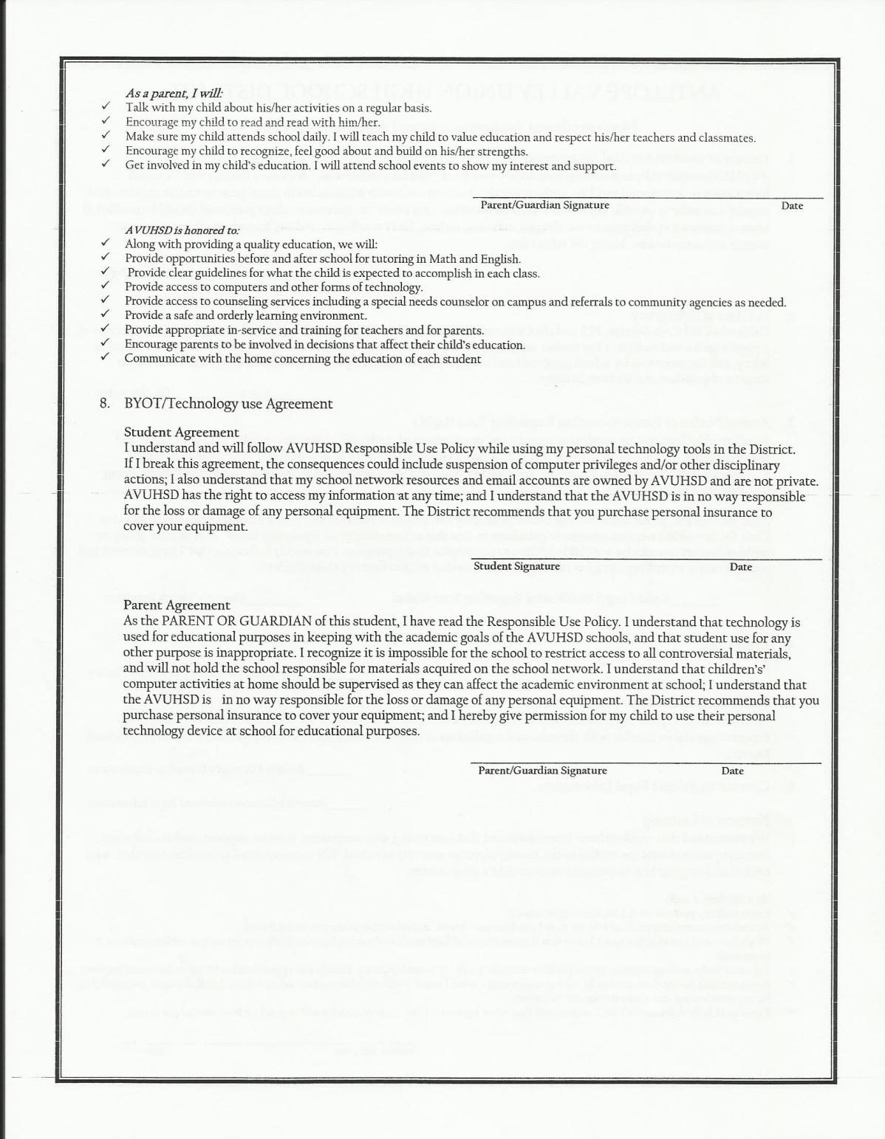

**Welcome to our High School!**

**Registration Instructions**

**The Registration Process for your Newly Enrolled Student at Antelope Valley High School now needs to be completed on-line.**  Attached, ***please find the Codes required* to Create your Parent Account** and the Instructions for doing so. You will use this account to review your Student’s Grades and attendance… as well as to contact Teachers. If you have any questions, or would prefer to come in and utilize the School’s Computers in the Guidance Center – where you can receive assistance - please don’t hesitate to do so. Registration is done Monday through Thursday from 7:30 to 10: 00 am. If you would prefer to complete this step at home, please log onto [**https://powerschool.avhsd.org**](https://powerschool.avhsd.org) and follow the instructions listed below…

* **Create Parent Account** You will need to create a “User Name” and “Password” of your choice. Please record these somewhere for your future use***. If you already have an account > your User Name is as follows:***

**User Name**: **Password**:

* **To Add your NEW Student you will need the following –**

***Access ID* #:**  ***Access Password*** #:

**\***(***If***Student has ***Siblings*** that ***already attend*** – parent will ***Sign into Account*** */* ***Select Account Preferences*** */****Select Student*** */then* ***“Add”*** *your* new student with the Access ID and Passwords below)

Next, indicate your relationship to the Student in the “drop down menu”… Click “*Enter”*

* **“Congratulations!” you’ve created your account** – ***please Log back on*** – *with*: *User Name and Password*
* Once PowerSchools opens up – Students name will be in Top Blue Bar on Left side of page – Scroll down to “InfoSnap Student Enrollment (**16 - 17**) and select.
* Once page has loaded… *Agree to Terms and Begin forms*
* Every Field that has a “Red Asterisk” **\* *needs to be answered***
* *Please complete Everything to the best of your Ability*
* Once the registration is complete – Parent / Guardian will *“SUBMIT” the Registration - if you are not allowed to go on any further please review… all fields that say* ***“required” have to be answered***
* You will be instructed to print the **“SIGNATURE Page”** (which is in **BLUE Font** ) click on these two words and once prompted to – *Open the Document*  – Print, Save and Log out of Program (if you do not have a Printer at home – you are Welcome to print this document at the School Site). ***You will also need to repeat this process for each school year that your child is enrolled in our district.***
* Take your completed “**Signature Page**” and other Documents to Clerk, Technician or Counselor and if you haven’t done so - you will be able to proceed with the rest of the Enrollment Procedure. Thank You for taking care of this Matter. We appreciate your cooperation.
* If you’d like **to** **apply for FREE / REDUCED Lunch** you may do so at **SchoolLunchApp.com** (in the *Drop-down* *Menu* – please select **ANTELOPE VALLEY UNION HIGH SCHOOL DISTRICT** – *Your Student ID # is the Access ID # listed above* ) AVHS Guidance /ls 01.27.16